

**TASK**

**Exploratory Data Analysis on the Google Trends Dataset**

[](http://www.hyperiondev.com/portal/)

**Introduction**

Summary of the data set: Description of Data: This is a curated dataset of Google Trends over the years. Every year, Google releases the trending search queries all over the world in various categories. It has trends from 2001 to 2020.

Trends data is an unbiased sample of Google search data. It’s anonymized (no one is personally identified), categorized (determining the topic for a search query) and aggregated (grouped together). This allows us to measure interest in a particular topic across search, from around the globe, right down to city-level geography. Trends data can provide a powerful lens into what Google users are curious about and how people around the world react to important events.

Source:

https://www.kaggle.com/datasets/dhruvildave/google-trends-dataset

https://medium.com/google-news-lab/what-is-google-trends-data-and-what-does-it-mean-b48f07342ee8

**Pre-Processing**

Utilized the below functions to preview and pre-process the data

Df. head()

Df.sample()

df['year'].unique()

df['category'].unique()

df.info()

df.nunique()

No missing data or inconsistent datatypes observed

**MISSING DATA**

No missing data or inconsistent datatypes observed

**DATA STORIES AND VISUALISATIONS**

1. Let’s start with getting a graph for all numerical values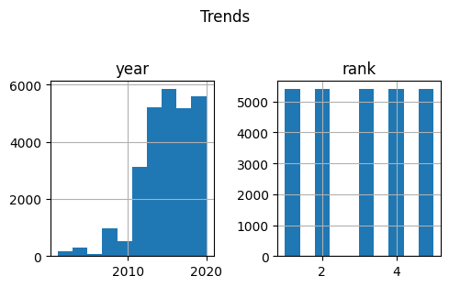

### Interpretation #1 - Google was used as main and dominant search provider in the later parts of 2000s - that explains the first graph

1. Since consumer brands was highlighted in the earlier df. head() function for the initial years of the search, let’s take a deeper dive into all "consumer" categories

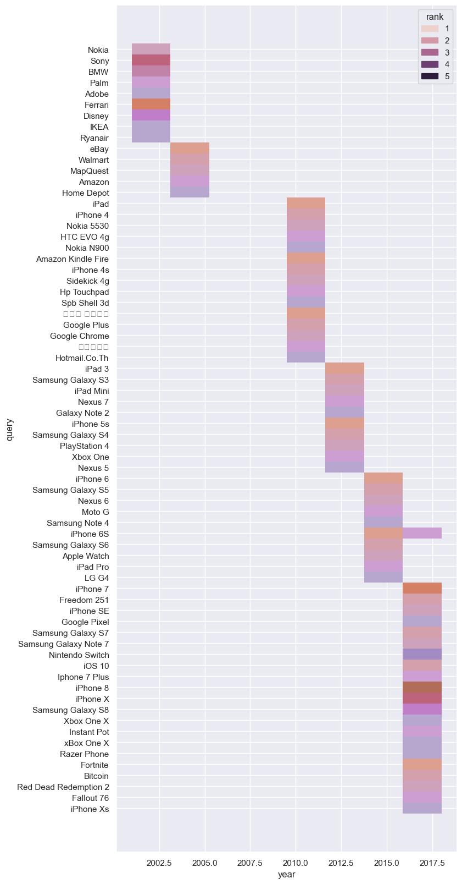

### Interpretation 2: The above graphs present an interesting story on how we shifted drastically from cars, Disney, IKEA, Ryan air kind of consumer brands initially into dominant "mobile phone devices" category - shows how mobiles have taken over our lives in a certain way! The sheer number of mobile devices search is staggering across all the years. Other notable mentions go to game stations (PlayStation/Xbox etc), Instant Pot and Bitcoin.

1. Let’s visualize it by consumer categories

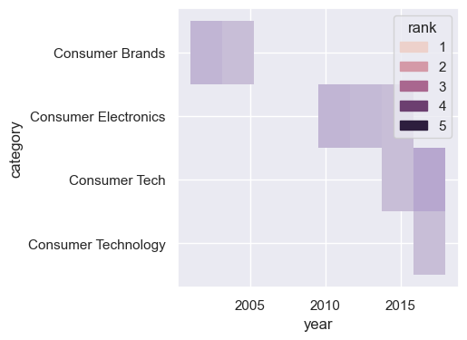

### Interpretation 3 - Indeed, the shift has moved from Consumer brands to Electronics to Technology.

1. ### Let’s move beyond consumer categories to check the top 20 categories that were searched over the years

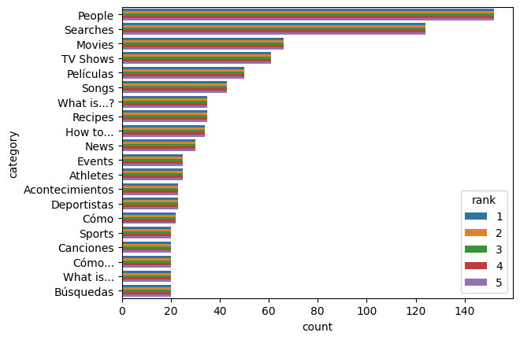

**### Interpretation #4 - Consumer categories did not reach the top 20 list. Could this mean that we have become less materialistic or is it the case that we used different mediums to search for consumer goods (amazon/apple store/fb marketplace etc.) instead of Google search - Perhaps another EDA on consumer brand search engines may answer. Equally interesting insight is that the top category goes to "People" - we are indeed very curious about others! Another notable insight is that 4 out of the top 6 categories are related to movies/films(peliculas)/songs. This tells us that we as a human race are very interested in entertainment!**

1. **Let’s take a look at the people we are interested in over the years**

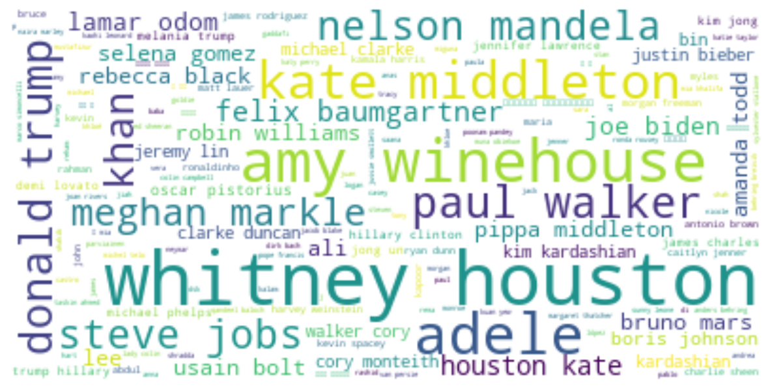

**### ### Interpretation 5 - Most of the people we are interested are not scientists, philosophers or entrepreneurs (barring Steve Jobs) unfortunately. It appears that we are influenced heavily by Celebrity Artists or Politicians. A sombre note is that a number of these celebrity searches relate to artists who has passed away, but it still shows the attachment we have towards celebrity artists**

1. **### Given the last few years have been taken over by Covid-19, let’s take a look at searches during year 2020 as the dataset ends at 2020**

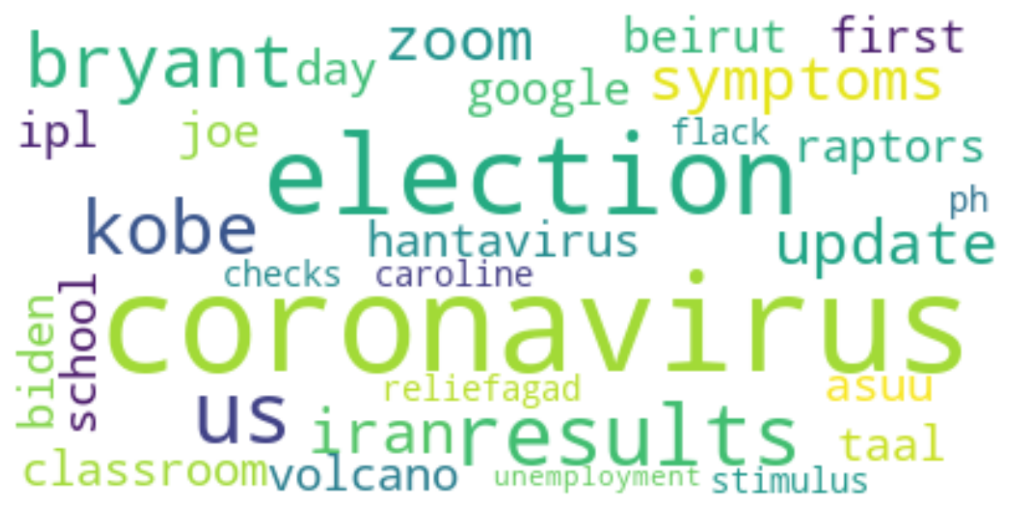

**### Interpretation 6 - While Coronavirus dominated the Searches and News, the other notable themes were around zoom, stimulus, checks, unemployment and US elections. It indicates the collective frame of our minds that when the world gets stopped due to Covid-19, we try finding ways to connect via zoom, help others and the economy via stimulus and checks.**

**### Interpretation 7 - In conclusion, based on this Google trends data analysis and the collective searches across the globe between 2001 - 2020, our search priorities have been dominated by mobile devices, gaming technology, movies while we are consumed by our interest in Celebrities and Politicians. The common thread that potentially binds all these themes is how its all centred towards our entertainment by people via movies, games or the great political theatre! And when we don't actively search for this entertainment, we search for platforms for entertainment i.e., 'mobile devices'. So, this analysis indicates that we use Search for entertainment or platforms of entertainment!**

**THIS REPORT WAS WRITTEN BY: Jennings Balavari on 21st February 2023**

